**NALAIYA THIRAN**

**Professional Readiness for Innovation, Employability and Entrepreneurship**

REPORT

WEEK-1

**Project Tile:** AI-powered Nutrition Analyzer for Fitness

Enthusiasts

**Team ID:** PNT2022TMID48053 GitHub ID: IBM-Project-53441-

1665376120

* ACCESSING THE RESOURCES IN PROJECT DASHBOARD

We got approval for our project from SPOC and accessed the project dashboard.

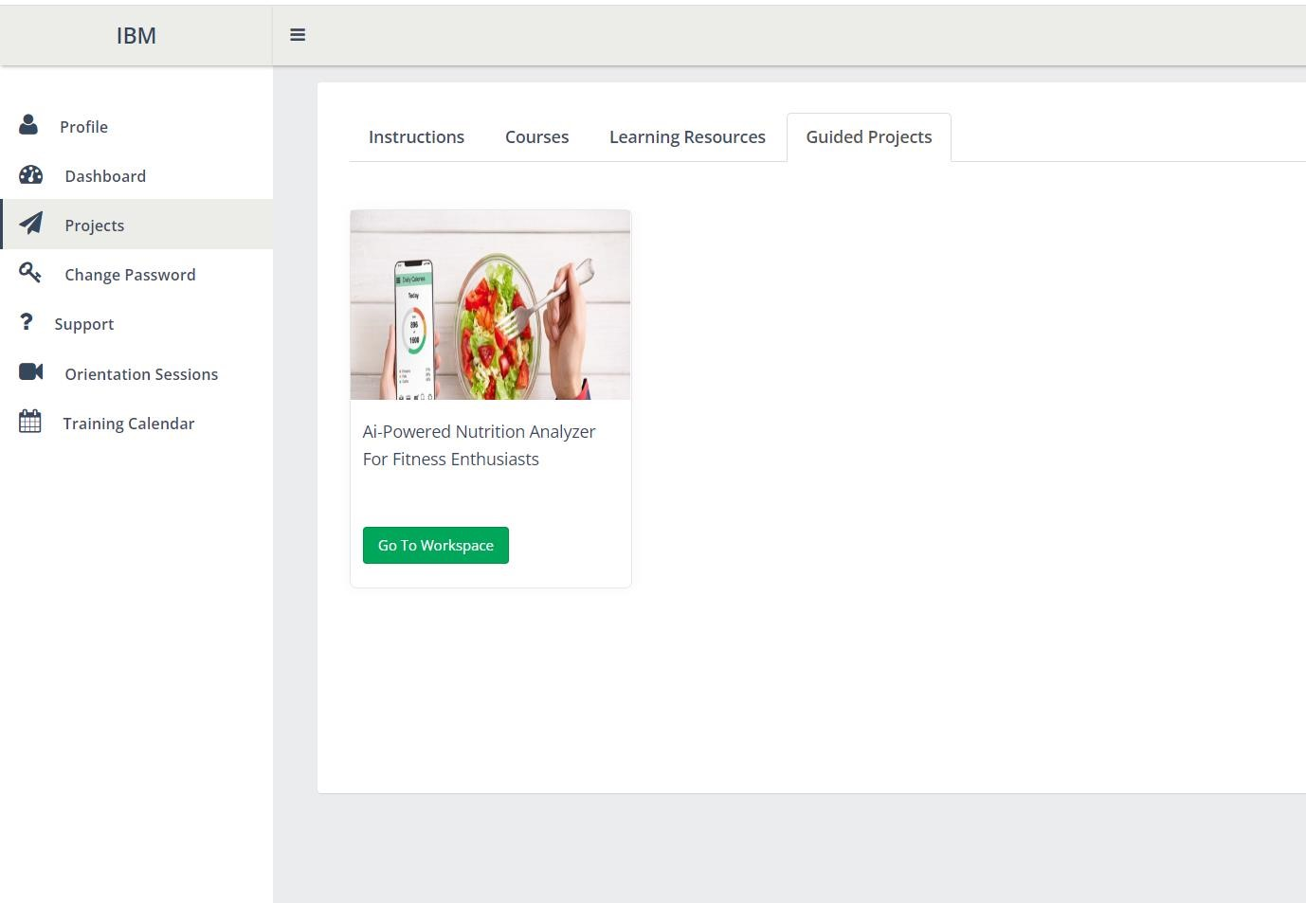

* Joining the mentoring channel via platform & rocketchat mobile app

We joined the mentoring channel via platform in dashboard.

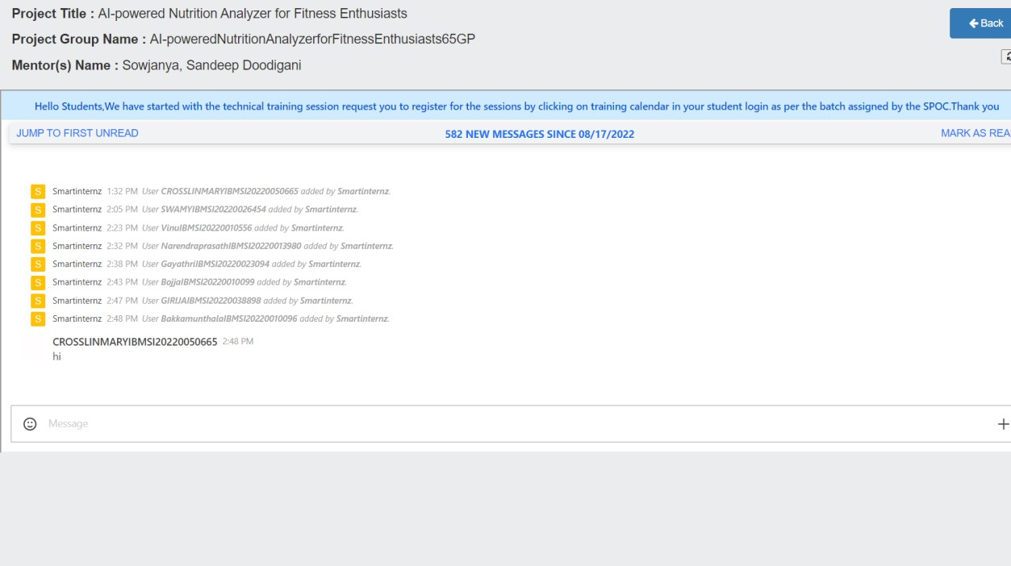

* Creating GitHub account & collaborate with Project Repository in project workspace

We have successfully created the GitHub account and collaborated with the whole team members and integrated with our project workspace.

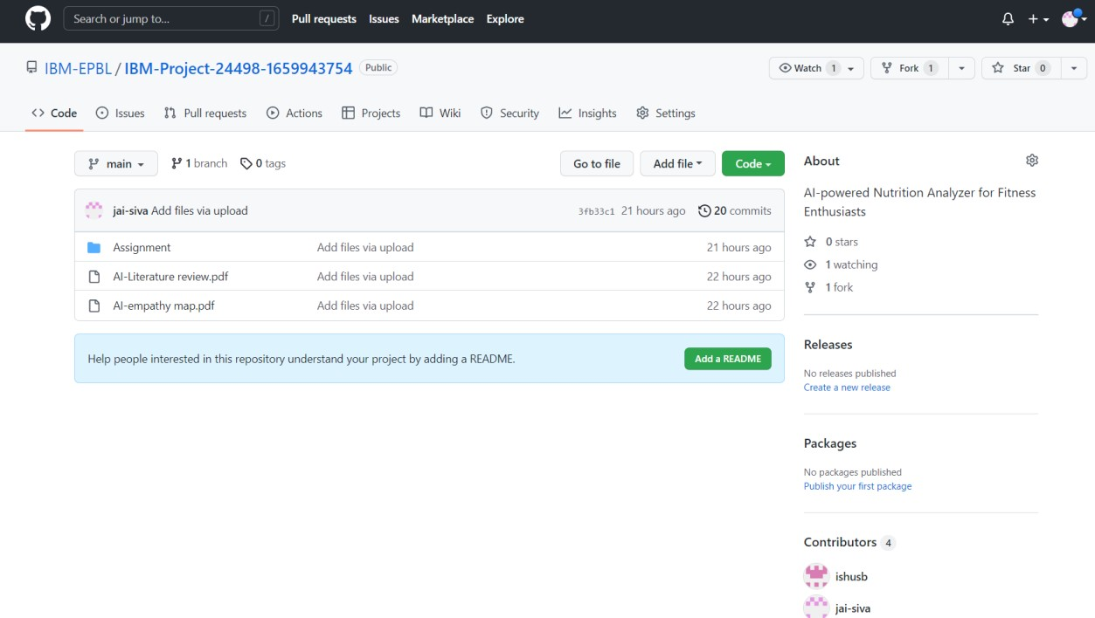

* Setting-up the Laptop / Computers based on the prerequisites for each technology track

We have downloaded the required prerequisites .